Design Doc Template

TALKING FINGERS

*Author(s): TEAM TALKING FINGERS*

*Date: 22/05/2019*

Revision: 0

Document Status: Draft [Draft, Completed, Submitted, Reviewed, Final]

Project Status: In-Progress [In Review, Approved, In-Progress, Completed]

Revision History

|  |  |  |  |
| --- | --- | --- | --- |
| Date | Revision | Description | Author |
| 22/05/2019 | 0 | Initial draft of the design doc template | xyz |
|  |  |  |  |
|  |  |  |  |
|  |  |  |  |
|  |  |  |  |
|  |  |  |  |
|  |  |  |  |
|  |  |  |  |
|  |  |  |  |
|  |  |  |  |

Table of Contents

Introduction4

Summary4

Background4

Definitions, Acronyms, and Abbreviations4

Design Overview4

Requirements4

Minimum Viable Product5

Stretch goals5

Future work5

Architectural Diagrams5

System Diagrams5

Application Programming Interface5

Recommendations5

User Interface6

Data Models and Storage6

Service Operability6

Key Performance Indicators6

Service Level Objectives6

Project Overview7

Communication and Tracking7

Risks7

Milestones7

Project Phases7

Cost7

Frequently Asked Question7

References7

Addendum8

# Introduction

## Summary

The communication barrier between Dumb and normal person is building day by day. If we could some how break the barrier then we are almost successful in removing the hardships of these dumb people. Our approach of creating a Device (DATA GLOVE) that converts the hand gestures performed by the dumb people into audio output based on INDIAN SIGNLANGUAGE. This process clearly helps people to understand what dumb people trying to say and there will be no barrier of communication

## Background.

PROBLEM STATEMENT:

To break the communication barrier between dumb and society .By finding a way to make the communication easier and simpler by making use of preferred sign languages.

There are no tools in the present society that solve this problem.

By creating this solution we can solve the communication problems of the deaf and dumb people and help in developing their lives and let them communicate with us.

## Definitions, Acronyms, and Abbreviations

MPU6050 – a sensor that estimates position of hand

ML – Machine learning

Sign language – Indian, American sign languages.

Raspberry pi – A microcontroller board.

# Design Overview

## Requirements

The requirements for this project include

Dataset: the dataset contains data obtained by recording various gestures

Gestures: knowledge of the different gestures and their meanings must be obtained from dumbschools or training centres

Embedded Systems: knowledge of miniaturizing the raspberry pi board through embedded systems is required

## Minimum Viable Product

The minimum viable product must produce audio output by recognizing the gestures that are given or input by the customer.

## Stretch goals

Adjusting to catch the speed of users hand and making the glove very compact with the cheapest price possible.

## Future work

We are looking to high rate the efficiency of hand gesture recognition by creating a large data set and make it as compact as possible by using embedded systems .

# Architectural Diagrams

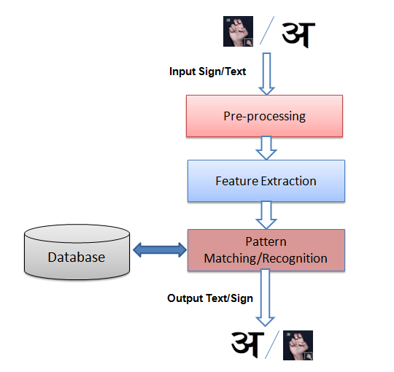

# System Diagrams

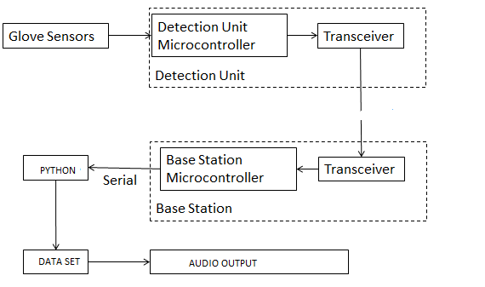

# 

# Application Programming Interface

POWER

SUPPLY

MPU 6050

MPU 6050

MPU6050

SPEAKER

RASPBERRY

PI

# Service Operability

## Key Performance Indicators

The key performance indicators for this project are the efficiency of recognizing the gesture of the algorithm.it can be known by testing the train cases against test cases.

## Service Level Objectives

Service level objectives of our product are knowing the efficiency of the product and also the processing time of the processor. The heating of the processor must also be checked.

# Project Overview

## Communication and Tracking

Slack: jhubexcite2019 - #talking fingers

Github: anonymoussai - jhubexcite2019 repository

## Risks

The main risks of our product are:

Maintaining all the connections properly and errors in the sensors or source code

External conditions and the usage of the product also affect its efficiency

## Milestones

Week 1: Plan the basic infrastructure of the project and figure out the I2C sensor

Week 2: research about the matrial used for gloves and the batteries to be used

Week 3: Market Research and training

Week 4: Trials and repairs if necessary

Week 5: Product ready for display

## Project Phases

Phase 1:

Increasing efficiency by using 3 sensors

Phase 2:

Miniaturizing the product

Phase 3:

Research about the batteries used and also the build of the product

Phase 4:

Testing the product

Phase 5:

Marketing the product

## Cost

Man hours:

210 hours of work approximately for the completion

Research: 40 hours for research on the gestures.

Materials: 20 hours for research on the materials to be used

Sensors: 70 hours for working on the programming and working of sensors

Training: 30 hours for training the ML algorithm

Testing: 50 hours for testing the final product and repairs.

Resources:

The prototype costs around 4065 Rs.

The final product will be available for an approximate price of 1500 after miniaturizing.

# Frequently Asked Question

1. Is the process automatic?
2. How fast is the reaction time?
3. How do the external conditions affect the product?
4. How many gestures can the product recognize?
5. Can the product form sentences?

# References

Machine learning course: <https://www.udemy.com/machinelearning/>

Sensor code: <https://github.com/Tijndagamer/mpu6050>

Speaker code: <https://www.rhydolabz.com/wiki/?p=10054>

#### Addendum

